
Power line carrier communication – pl 9500

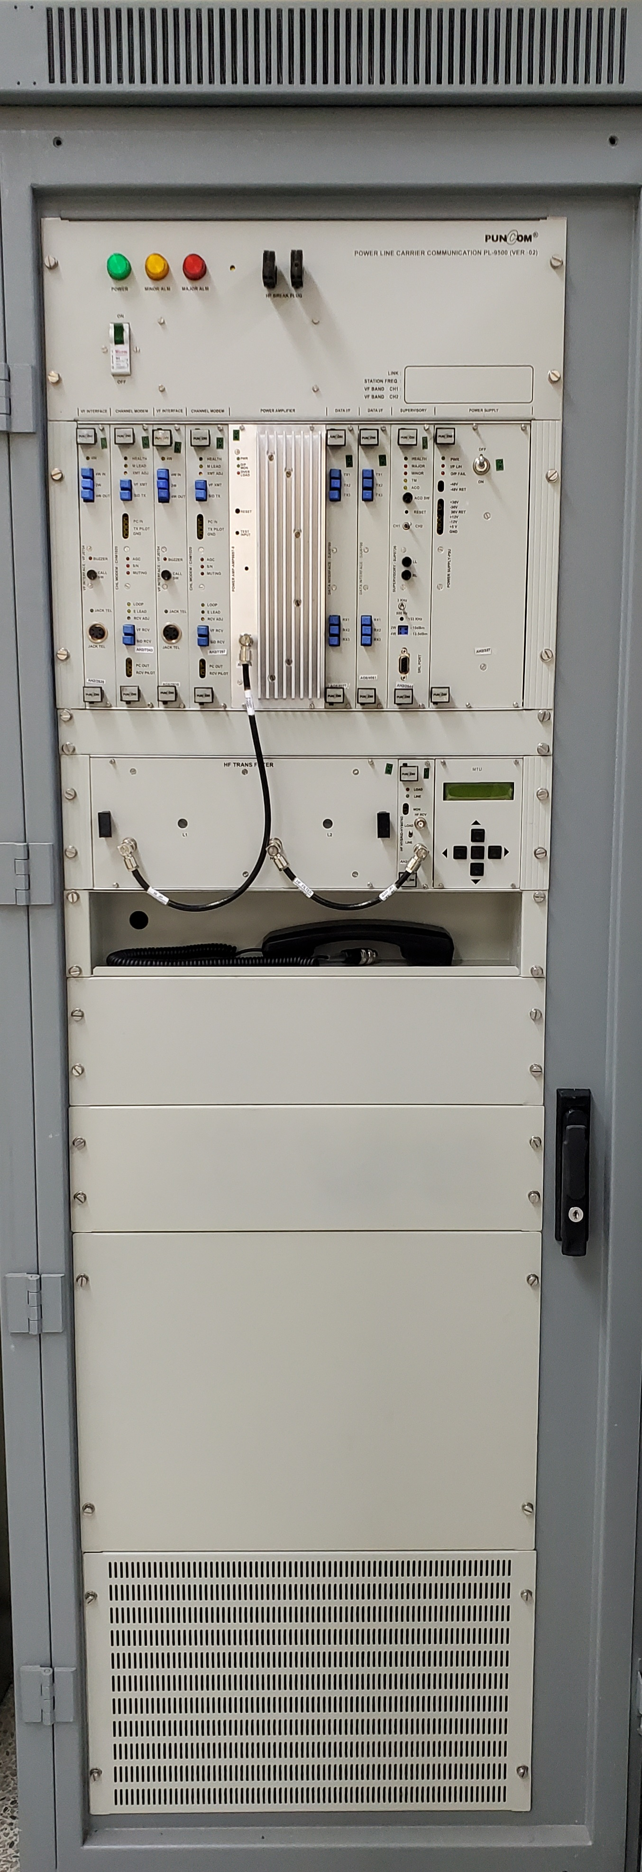

Power Line Carrier Communication Equipment PL-9500 is a new generation equipment for carrier transmission and reception of Speech, Facsimile, RTU data, and tele-protection signals in frequency range of 32 KHz to 508 KHz over high voltage overhead transmission lines. The system offers a single channel expandable to two channels for full bandwidth Speech / Fax or Shared Speech-cum-superimposed data channel or one high-speed 4-wire exclusive data channel of 1200 bauds. The superimposed data channel can support upto 600-baud (2160-3700 Hz) channel as a backup for RTU/SCADA on wideband communication links. PL-9500 can be used either as a terminal equipment or as Drop / Insert through a coupled repeater.

features
- Local and Remote loop-back facility.
- Can transmit trip signals from Distance Protection Scheme (Network) for the protection of high voltage transmission lines.
- Supervisory unit facilitates easy maintenance and operation.
- Extensive use of Integrated Circuits and Crystal filters ensures high quality and reliability of equipment.
- Compliance with relevant ITU-T, IEC and IS standards.
- Fully complies to the relevant EMI & EMC standards.
- Availability of Normal Rack as well as Swing Rack.
- Single or dual channel configurations.
- 32 KHz to 508 KHz frequency range with 1 KHz frequency allocation steps.
- 20/40W PEP power at Line output.
- On site configuration of channel frequencies and transmission levels.
- Field programmable VF upper cut off through switch selection.
- DSP based circuitry for field programmable pilot & transit band pass filters.
- Remote extension of direct EPABX lines, Hot Line, Express Channels and 2W/4W E&M modes available on same VF interface unit.
- Ease of installation and maintenance.
power line carrier communication – pl 9500
SPECIFICATIONS
GENARAL INFORMATION |  |  | GROUP DELAY
Multiplexing  Channel Capacity  Modulation  VF-Band  Speech Bandwidth | Analog, Frequency Division  Upto 2 Channels  AM, SSB Supressed carrier  300 – 3720 Hz  300 – 2000 Hz, 300 – 2200 Hz  300 – 2400 Hz, 300 – 3400 Hz |  | 500-600 Hz  600-1000 Hz  1000-2600 Hz  2600-2800 Hz | 3 mSec. (Maximum)  1.5 mSec. (Maximum)  0.5 mSec. (Maximum)  2.5 mSec. (Maximum)
 |  |  | SIGNALLING PILOT
 |  |  | Signaling Frequency  Pilot Frequency  Level  Distortion at 10 pps,  (50/50 Break / Make)  AGC Range  Input  Output | 3825 Hz  Programmable (2160, 2220  2580, 3360, & 3780 ±30Hz)  -14 dBm0  <5.0 mSec (5%)  -26 to +14 dB  ± 1.0 dB

HF INTERFACE
Impedance  Output Power to Line  Transmission Level (40W Version)  Receiver Sensitivity  Return Loss  Carrier Stability  Carrier Leak  Medium  Tapping Loss (for parallel connection of an additional PLCC equipment) | 75 / 125 Ohms (Unbalanced) or 150 Ohms (balanced) 20 / 40W PEP  + 38 dBm  -43 dBm  12 dB minimum  ± 2 ppm over the temperature range of 0° to 50° C  Better than –45 dBm0  66/132/220/440 KV HVTs  <1.5 dB at Δf ≥ 8 KHz  <1.5 dB at Δf ≥ 8 KHz
 |  |  | NOISE PERFORMANCE
 |  |  | Idle Noise  Cross Talk  Side Tone (HF Terminated)  Out of Band Spurious | Better than –55 dBm0p without compander  Better than –65 dBm0p with compander  Better than –50 dBm0p  Better than –40 dBm0p  Better than –60 dBm0p

VF INTERFACE
2W Transmit Level  2W Receive Level  2W Impedance  2W Return Loss  4W Transmit Level  4W Receive Level  4W Impedance  4W Return Loss  Frequency Response  (Without Companders)  300-400 Hz  400-600 Hz  600-2400 Hz  2400-3000 Hz  3000-3400 Hz  Linearity (-10 to –3.0 dBm0 input)  Limiting  End to End Frequency Deviation | -13.5 to +8.0dBm, 0dBm (Nom.)  -17.0 to +4.5dBm, -7dBm (Nom.)  600 Ohms  14dB minimum  -17.0 to 8.0dBm, -3.5dBm (Nom.)  -17.0 to +8.0dBm, -3.5dBm (Nom.)  600Ohms  20dB minimum  -0.9 to +3.0 dB  -0.9 to +1.70 dB  -0.9 to +0.9 dB  -0.9 to +1.7 dB  -0.9 to +3.0 dB  ± 0.5 dBm0  Starts above –3 dBm0 at 2W input  2 Hz maximum
 |  |  | Power supply
 |  |  | Input Voltage  Power Consumption  (For 20W Version)  (For 20W Version) | -48V Nom. (-40V to –60V)  160W (for twin channel system)  220W (for twin channel system)
 |  |  | MECHANICAL
 |  |  | Rack Size  Color of Rack | Height : 1908mm  Width : 690mm  Depth : 500mm  Swing Rack - Outside: Aircraft Grey Powder coating, Inside: Eggshell white
 |  |  | ENVIRONMENTAL
 |  |  | Meets all specs.  Operational  Storage  Humidity | 0° C to +50° C  -10° C to +55° C  -25° C to +65° C  95% max. at 40° C
Specifications subjected to change without notice. (07092012) NOTE: Specifications hold for a pair of end to end terminals excluding coupling equipment and HV lines impairment.

Punjab Communications Limited

B-91, Phase VIII, Industrial Area, S.A.S. Nagar (Punjab) 160 071 India
Phones : +91-172-2237101 (8 lines), Fax : +91-172-2237125, 3046919
e-mail : marketing@puncom.com

Visit us at our internet site : www.puncom.com

